

***In this issue >>>***

***Around the Agency***

***Giving Tuesday***

***Agency/Donor Spotlight***

***Tips for Parents***

***We are looking forward to…***

***Carrie’s Corner***

***Recipe of the Month***

*Around the Agency*

**October 2022**

**Eleven**

We would like to thank the Assistance League of Riverside for their donation of gifts to our graduates and their assistance in hosting our Graduation gathering. Their kindness and generosity helped each youth feel accomplished and supported.

**Congratulations to:**

**Paul H.**

**Hannah J.**

**Jada K.**

**Vincent M.**

**Zaire H.**

**Max G.**

The Heart Matters is proud to announce that 7 of our teens graduated this year. We are proud of what these young adults have accomplished and have high hopes for their futures.

Issue

***Back to School***

The Heartbeat

**The Official Newsletter of The Heart Matters Foster Family Agency**

***Our Mission: To provide safe homes, healing and healthy environments and encouraging youth empowerment.***

**Giving Tuesday is November 29th**

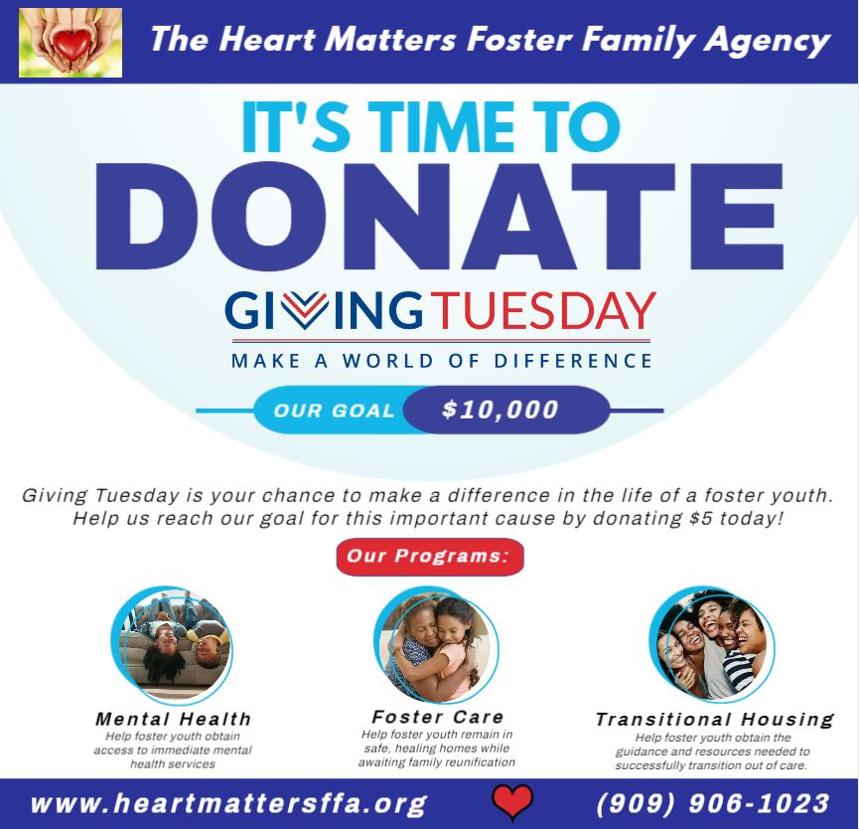

This Giving Tuesday, help us reach our goal of $10,000 to help support the foster youth of the Inland Empire. The Funds raised will assist in continuing our many programs, but specifically our Transitional Housing Program which helps current and former foster youth between the ages of 18-21 successfully transition out of care. This program provides each participant with a fully furnished apartment, access to an employment and education specialist, an assigned evolution coach, and a bi-monthly stipend to help with everyday costs such as transportation, groceries, school supplies, work uniforms, laundry services, and much more!

**Agency Spotlight – Disney Days!**

On September 25, 2022,

Our agency was blessed to be one of the few chosen to participate in Together We Rise’s Disney Days! This event is hosted each year and helps siblings separated in foster care be reunited and enjoy a day of fun, laughter, and joy.

Our youth loved spending the day with their siblings at the happiest place on earth. The day was filled with surprises and treats as our youth received sunglasses, lanyards, ice cream, souvenirs, and much more!

We are grateful to have this relationship with Together We Rise to present opportunities like this to those who would not have this experience otherwise.

Thank you Together We Rise!



**Donor Spotlight: Heart of a Superhero**

The Heart Matters would like to announce our newest Heart of a Superhero:

**San Manuel Band of Mission Indians.**

The Heart Matters Foster Family Agency has the pleasure of being a grant recipient of San Manuel Band of Mission Indians. Their generous donation will help foster youth between the ages of 18-21 within our Transitional Housing Program purchase items such as gas, groceries, transportation, laundry services, cleaning supplies, and much more.

In a time where inflation is rising the cost of goods and services, the help of San Manuel could not come at a better time. Our youth and staff would like to thank them for their support and assistance to those working towards independence.



In addition to planning for safe costumes, trick-or-treating safety, and candy safety this Halloween, there are other important ways to keep your family safe this Fall.

**Germs**I know you’ve heard it before, but it is worth repeating clean hands save lives! Kids (those adorable little viral vectors) are back in school now, coughing and sneezing all over each other. Help protect your children from getting sick by teaching them to wash their hands often and to keep their hands away from their nose and mouth. Help them learn to cough into their elbow instead of their hand. And please keep them home if they are sick—their friends (and their parents) thank you.

**Road Safety**With the sun setting earlier these days, it’s likely the kids will be walking home from the bus stop or playing outside after dark. They should only walk on the sidewalk or facing oncoming traffic and should be sure to wear light colored clothing and/or reflective tape on their front and back, so they can be easily seen. Children under the age of 10 should not be allowed to cross a street without supervision.

Also, with autumn brings the return of jackets, fluffy coats, hats, mittens. And reminders about taking off said fluffy coats before clipping your kids into their car seats. All that fluff will compress in an accident, leaving the straps too loose and not protecting your children.

**Fire Safety**With the weather getting colder, it’s time to think about lighting fires. Before using your fireplace or wood stove, be sure to have your chimney inspected and cleaned. Make sure that there is a wide barrier (such as a child gate) around the fire and always supervise children to keep them safe from burns. The changing of the clocks for daylight savings is a great reminder to change the batteries in your smoke detectors and carbon monoxide detector. They should also be tested monthly.

https://www.beebehealthcare.org/health-hub/autumn-safety-tips-parents

Credit: https://www.istockphoto.com/photos/fall-festival-kids

**Tips for Parents**

**We are looking forward to…**

*

Dear Amazing Families, Partners, and Staff,

This last quarter has had its surprises. Our Back-to-School event was a success as we provided over 80 youth with backpacks, supplies, and brand-new shoes to start off the new school year. Dave & Busters and Ontario Mills were a pleasure to work with and spoiled our youth and families with food and game cards. On the other hand, our staff, families, and partners were saddened to hear that our Trunk-or-Treat event had to unfortunately be cancelled. We were amazed by the response we got from this event, though, and hope to present it next year for all to enjoy.

As one season ends, another begins. Our staff is geared up and ready to make this another wonderful holiday season for the foster youth and families within our agency. While we host many events and drives throughout the year, the holidays are no doubt our favorite. We have already collected wish lists from all our youth and are working hard to grant each one of them through the many drives being hosted throughout the Inland Empire. I would like to take this time to thank all our amazing donors who have started early this year to help us reach our goal of over 300 wishes granted! You all are truly amazing, and we could not do all that we do without you.

If I do not see you before,

I hope you all have an amazing holiday season and happy new year!

*Carrie Mathews, MPA*

*Executive Director*

***A Note from Our Executive Director***

*Carrie’s Corner*

With Love,

Carrie

❤❤❤

Recipe of the Month

**Toddler Muffin by Mom Envy**

**Ingredients**

¼ cup butter, softened

¼ cup applesauce

½ cup brown sugar, or to taste

2 large bananas, mashed

¾ cup pumpkin puree

2 carrots, grated (10-12 baby carrots)

2 eggs, beaten

1 cup flour

½ cup instant oats

1 teaspoon baking soda

1 teaspoon cinnamon

½ teaspoon salt

**DIRECTIONS**

1. Preheat oven to 375 degrees F. Grease 24 mini muffin cups or 12 standard muffin cups.
2. In a mixing bowl, cream together the butter, applesauce, and brown sugar until smooth.
3. Mix in the mashed bananas, pumpkin, carrots, and eggs.
4. 4 Stir in the flour, oats, baking soda, cinnamon, and salt until just combines
5. Spoon the batter equally into the prepared muffin cups and bake for 15 – 20 minutes, or until a toothpick inserted into the center comes out clean.
6. Cool pans for 10 minutes before removing.

**The Heart Matters Foster Family Agency**

**21935 Van Buren St, Suite A-1**

**Grand Terrace, CA 92313**

**909-906-1023**

[www.heartmattersffa.org](http://www.heartmattersffa.org)

Lic.#366427925

